**HOSPITAL Appointment BOOKING** **SYSTEM**

**Abstract**

This project is a web-based Hospital Appointment Booking System designed to streamline administrative and operational tasks in healthcare facilities. Built using Node.js with Express.js as the backend framework, the application integrates MongoDB for database management. The system provides functionalities such as user authentication, appointment scheduling, and service management.

The backend ensures secure handling of sensitive data through JWT-based authentication and bcrypt for password encryption. Static files for the frontend are served using Express, enabling a seamless user experience. The project also incorporates environment variable Appointment Booking Systemthrough the `dotenv` package, ensuring secure configuration.

The application aims to enhance efficiency in hospital operations by offering a centralized platform for patients, doctors, and administrators to interact effectively while maintaining data security and scalability.

Here’s a detailed introduction you can use for your *Hospital Appointment Booking System* project. This is written in a professional and informative tone, suitable for including in a project report, website documentation, or presentation

**Introduction**

In today’s fast-paced world, timely access to healthcare services is essential. The *Hospital Appointment Booking System* is a web-based platform designed to streamline and simplify the process of scheduling medical appointments. This system is particularly useful for patients, doctors, and hospital administrative staff, enabling more efficient communication and better time Appointment Booking Systemwithin the healthcare environment.

This project leverages HTML, CSS, and JavaScript on the front end for creating a responsive and user-friendly interface, while the backend is developed using *Node.js* with *Express.js* to handle server-side operations. It also supports integration with *MongoDB*, a NoSQL database, for storing and retrieving user and appointment data. The application allows patients to create accounts, log in securely, view available doctors and services, and book appointments. Once an appointment is booked, the system can also notify users how many days remain before their scheduled visit, helping patients stay organized and avoid missed consultations.

The platform includes a clean and intuitive navigation system, with dedicated pages for:

* **Home Page** – An overview of the hospital's services and facilities.
* **About Us** – Information about the hospital, its mission, and its healthcare professionals.
* **Services** – A detailed list of healthcare services offered.
* **Doctors**– Profiles of available doctors.
* **Appointment Booking** – A form for patients to schedule consultations.
* **Login/Logout System** – Secure access to personalized features.
* **Welcome Page** – A post-login dashboard that displays personalized messages and upcoming appointment details.
* **Contact Page** – A form to reach out to the hospital for queries or support.

Additionally, the backend includes a .env file for managing environment variables securely and a server.js file that powers the application logic, such as handling form submissions and connecting to the database.

By digitalizing the appointment process, this system reduces administrative burdens, minimizes patient wait times, and ensures that the hospital staff can manage schedules more effectively. It is a valuable tool for modern healthcare Appointment Booking Systemand an essential step towards the digital transformation of hospitals and clinics.

**Design**

The *Hospital Appointment Booking System* is designed with a modular and scalable architecture to provide a seamless user experience for both patients and hospital staff. The system follows a simplified but effective MERN-inspired architecture, utilizing *MongoDB, **Express.js, and **Node.js* on the backend, with a custom-built HTML/CSS/JavaScript frontend. Each component plays a key role in enabling secure and efficient interactions between users and the system.

**Architecture Overview**

**Frontend:**

The user interface is developed using HTML, CSS, and vanilla JavaScript. Bootstrap is used for responsive styling, ensuring the design is intuitive and accessible across various devices. Users interact with multiple pages such as the homepage, login, registration, appointment form, and welcome dashboard.

**Backend:**

Node.js and Express.js handle server-side logic, manage routing, and process form submissions. Express middleware manages requests and validates inputs, while secure endpoints facilitate authentication and data handling.

**Database:**

MongoDB is used to store structured data such as user credentials, appointment records, and login sessions. Its NoSQL document structure allows easy expansion of features like storing medical history, feedback, or reminders in future iterations.

**API Layer:**

RESTful APIs serve as the bridge between frontend and backend. They manage operations like registering a new user, logging in, booking an appointment, and retrieving personalized data such as welcome messages and appointment countdowns.

**User Interface Design**

**1**. **Login & Registration Pages**

- Clean and simple UI with validation checks.

- Error prompts for incorrect credentials or missing fields.

- Secure login handled using session or token mechanisms.

**2.** **Appointment Page**

- Form for entering patient details and selecting appointment dates.

- Validates input and checks for scheduling within the next 15 days.

- Submits appointment data to the server and stores it in MongoDB.

**3**. **Welcome Page**

- Displays a personalized greeting using the user’s full name.

- Calculates and shows remaining days until the next appointment (if any).

- Includes navigation, a branded logo, and footer for consistency.

**4.** **Contact Page**

- Allows users to send inquiries or feedback.

- Backend receives and processes form submissions (email handling can be added optionally).

**5.** **Doctor & Services Pages**

- Static pages listing available services and doctor profiles.

- Useful for patients to explore offerings before booking.

**Backend API Design**

**Authentication** **Routes**

- POST /register – Registers a new user.

- POST /login – Authenticates the user and starts a session.

- GET /logout – Ends the session and redirects to login.

**Appointment Routes**

- POST /book – Submits an appointment to the database.

- GET /appointment/:id – Fetches appointment details for a specific user.

- GET /welcome/:id – Returns user data and remaining days to appointment.

**User Routes**

- GET /user/:id – Retrieves user profile information.

- DELETE /user/:id – (Future) Account removal or data reset.

**Security Design**

**Session Management:**

- Uses session cookies or JWT (based on implementation) to manage authenticated access.

- User remains logged in until manual logout or session expiry.

**Input Validation & Error Handling:**

- Frontend and backend input validation to prevent malformed data.

- Protection against XSS, basic injection attempts, and unintended input.

**Environment Configuration:**

- .env file used to securely store database connection strings and secret keys.

**UI/UX Considerations**

**Responsive Design**:

The system is designed to function smoothly across various devices, including desktops, tablets, and mobile phones. The layout adapts to different screen sizes using responsive web design principles, ensuring accessibility and usability for all users.

**User-Friendly Navigation**:

The interface follows a clean and intuitive structure, with clearly labeled navigation bars, buttons, and forms. Each page—such as login, appointment booking, services, and contact can be accessed easily, enhancing user satisfaction and engagement.

**Consistent Styling**:

The use of Bootstrap and custom CSS ensures a visually cohesive experience. Fonts, buttons, and form fields maintain a uniform design throughout the site, reinforcing clarity and professionalism.

**Personalized Dashboard (Welcome Page**):

After login, users are greeted by their full name and informed about any upcoming appointments. This personalization improves the sense of user connection and system reliability.

**Future Enhancements**

**Online Payment Integration:**

- Incorporate secure payment gateways to allow patients to pay consultation fees online while booking appointments, enabling a complete end-to-end experience.

**Real-Time Appointment Slot Availability:**

- Implement dynamic slot visibility to show real-time availability based on doctor schedules and previously booked slots. This helps avoid conflicts and overbooking.

**Admin Dashboard:**

- Add an administrative panel where hospital staff can manage appointments, doctors’ schedules, and patient records, along with generating reports and analytics.

**SMS/Email Notifications:**

- Set up automated reminders and confirmations via SMS or email to inform users about appointment bookings, changes, or cancellations.

**Multilingual Support:**

- Extend accessibility by supporting regional languages, ensuring the system is inclusive for users from diverse linguistic backgrounds.

**Doctor Availability Calendar:**

- Provide an interactive calendar showing available time slots for each doctor, helping patients choose their preferred time more easily.

**Modules**

The **Hospital Appointment Booking System** is structured into various modules to ensure smooth functionality, easy maintenance, and future scalability. Each module is responsible for specific features, contributing to an overall efficient and user-centric experience.

**1. Authentication Module**

**Purpose:**

- Manages user registration, login, and session handling.

**Features:**

- User registration with validation and error handling

- Secure login with session or JWT-based Appointment Booking System

- Logout functionality to end the session and protect user data

**API Endpoints:**

- POST /register – Registers a new patient

- POST /login – Authenticates the user and creates a session/token

- GET /logout – Logs out the user

**2. User Appointment Booking SystemModule**

**Purpose:**

- Handles user profile and session-related data.

**Features:**

- View full name and appointment details after login

- Session validation to ensure secure access to protected pages

- Update user information (in future enhancements)

**API Endpoints:**

- GET /user/:id – Fetches user profile data

- POST /user/update – (Planned) Updates user profile

**3. Appointment Booking Module**

**Purpose:**

- Enables patients to schedule, view, or manage appointments.

**Features:**

- Appointment form for entering name, date, contact, and doctor

- Stores booking data into MongoDB

- Verifies that appointments are scheduled within a valid time window (e.g., 15 days)

**API Endpoints:**

- POST /appointment/book – Books an appointment

- GET /appointment/:userId – Retrieves booked appointment details

- DELETE /appointment/:id – (Planned) Cancels or updates a booking

**4**. **Welcome Dashboard Module**

**Purpose:**

- Displays a personalized welcome page with appointment tracking.

**Features:**

- Shows user's full name and upcoming appointment details

- Displays countdown of days remaining until the appointment

- Contains navigation bar, hospital logo, and footer for consistent layout

**API Usage:**

- Consumes appointment and user data to dynamically update UI

- Uses server logic to calculate days remaining

**5.** **Contact and Inquiry Module**

**Purpose:**

- Allows users to reach the hospital for queries or support.

**Features:**

- Contact form for submitting name, email, and message

- Backend handles message reception (email service integration optional)

**API Endpoints:**

- POST /contact – Sends inquiry to backend (email integration optional)

**6. Services and Doctor Listing Module**

**Purpose:**

- Displays static information about hospital services and available doctors.

**Features:**

- Lists of medical services offered

- Profiles of doctors with specialties and availability info

- Helps patients make informed decisions before booking

**7. Admin Panel Module (Optional/Future Enhancement)**

**Purpose:**

- Provides hospital administrators tools to manage appointments and users.

**Features:**

- View all appointments and patient records

- Manage doctor schedules and booking slots

- Generate analytics reports on patient inflow and service usage

**API Endpoints:**

- GET /admin/users – Retrieves user list

- GET /admin/appointments – Retrieves all appointments

- POST /admin/update-schedule – Updates doctor availability

**8. Notification Module (Optional/Future Enhancement)**

**Purpose:**

- Sends alerts and reminders to users regarding appointments.

**Features:**

- Email/SMS confirmation on booking

- Reminders for upcoming appointments

- Notifications for cancellations or doctor unavailability

**9. Payment Integration Module (Optional/Future Enhancement)**

**Purpose:**

- Enables secure online payment for consultation and appointment booking.

**Features:**

- Integration with payment gateways (e.g., Razorpay, PayPal)

- Generates invoices for booked appointments

- Supports UPI, debit/credit cards, and net banking

**Module Interaction Flow**

**1.** **User Authentication:**

Users register or log in → Session/token created and stored

**2. Appointment Booking:**

User fills the booking form → Server validates and stores appointment

**3. Dashboard Interaction:**

Welcome page displays personalized message → Remaining days calculated → Appointment details shown

**4. Contact:**

Contact with the hospital email and phone number

**5. Admin Control (Future):**

Admin logs in → Views appointment statistics → Manages data

**Architecture**

The **Hospital Appointment Booking System** follows a **three-tier architecture** that ensures modularity, scalability, and secure Appointment Booking Systemof patient data and appointments. The architecture is composed of three primary layers:

**1. Presentation Layer (Frontend)**

This layer is responsible for user interaction through a dynamic and responsive interface. It is developed using:

* HTML5, CSS3, and JavaScript – for page layout, styling, and interactivity
* Bootstrap– for responsive design and consistent styling
* JavaScript (Fetch API) – to handle asynchronous requests without reloading the page

**Key Components:**

* Login & Registration Pages – Handles user sign-up and login with validations
* Appointment Form – Allows users to book appointments with doctors
* Welcome Dashboard– Displays username and appointment details with remaining days
* Contact Us Page – Enables users to send inquiries or feedback
* Navigation Bar & Footer – Ensures consistent layout across all pages

**Communication Flow:**

* Sends requests to backend APIs for registration, login, booking, and profile fetch
* Dynamically updates UI with appointment data and messages
* Handles session-based navigation and redirection

**2. Application Layer (Backend)**

This layer bridges the frontend and database. It processes requests, applies business logic, and communicates with MongoDB. It is built using:

* Node.js & Express.js – To create and manage RESTful API endpoints
* JWT Authentication – For secure user sessions and route protection

**Key API Endpoints:**

**Authentication APIs:**

* POST /register – Registers a new user
* POST /login – Authenticates user and issues token

**Appointment APIs:**

* POST /appointment/book – Books an appointment
* GET /appointment/:userId – Retrieves user's appointment

**Profile APIs:**

* GET /user/:id – Fetches user details for the dashboard
* GET /logout – Ends the user session

**Business Logic:**

* Validates booking dates (within 15-day window)
* Calculates and returns the number of days left before the appointment
* Protects sensitive endpoints via token validation
* Handles error messaging and user redirection

**3. Data Layer (Database)**

This layer is responsible for storing and retrieving persistent data. It uses:

- MongoDB (NoSQL) – Flexible, document-based database

-Mongoose – ORM for schema creation and DB interaction

**Database Collections:**

1. Users Collection:

- Stores patient credentials (with hashed passwords)

- Contains full name, email, contact, and token data

2. Appointments Collection:

- Stores appointment records: name, date, doctor, contact

- Includes timestamps to calculate expiration or time left

3. Messages (Contact Form) Collection (Optional):

- Stores user inquiries or feedback messages

**Data Flow in the System**

**1. User Authentication:**

- User submits login form → Backend verifies credentials → JWT token issued → Token stored in browser

**2. Appointment Booking:**

- User submits form → Backend validates date → Saves to DB → Success response sent

**3. Dashboard Interaction:**

- After login, system fetches user and appointment data → Calculates days remaining → Displays welcome message

**4. Contact Form Submission:**

- User fills form → Request sent to backend → Stored or emailed to admin (future feature)

**5. Session Handling:**

- Token checked on each protected route → Invalid tokens redirect user to login page

**High-Level Architecture Diagram**

┌─────────────────────────── ┐

│ Presentation Layer │

│ (HTML, CSS, JS, Bootstrap) │

└────────────┬──────────────┘

│

▼

┌───────────────────────────┐

│ Application Layer │

│ (Node.js + Express.js) │

└────────────┬───────────── ┘

│

▼

┌───────────────────────────┐

│ Data Layer │

│ (MongoDB + Mongoose ORM) │

└───────────────────────────┘

**Security and Session Management**

- JWT Authentication: Used to verify user identity and protect sensitive routes

- Input Validation: Ensures safe data and prevents XSS/Injection attacks

- Session Timeout: Can be implemented to expire tokens after a set duration

**Scalability and Future Enhancements**

- Microservices Architecture: Future modules like doctor scheduling, billing, and notification can be modularized

- Cloud Deployment: Host backend and database on platforms like AWS or MongoDB Atlas

- Email & Payment Integration:Send email confirmations and accept payments for appointments

This architecture ensures a secure, modular, and user-friendly hospital appointment booking experience that is easily extendable to support advanced features in the future.

**Technologies**

The Hospital Appointment Booking System is built using a combination of modern web technologies to ensure a secure, seamless, and responsive experience for patients and administrators. The stack combines powerful frontend tools, a scalable backend, and a flexible NoSQL database.

**1. Frontend Technologies (Presentation Layer)**

The frontend offers a user-friendly interface that allows patients to interact with the system and manage their appointments easily.

**Technologies Used:**

- HTML5 – Structures the web pages and forms (login, registration, appointment booking)

- CSS3 – Styles the pages and ensures a visually consistent and appealing UI

- JavaScript (Vanilla JS)– Adds interactivity and handles dynamic DOM updates

- Bootstrap (Optional)– Enhances design with responsive layouts and UI components

- Fetch API / AJAX – Manages asynchronous requests to the backend APIs without reloading the page

**Key Features:**

- Fully responsive layout for mobile, tablet, and desktop

- Dynamic UI updates for showing usernames, appointment confirmations, and countdowns

- Clean navigation, footer, and branding for an intuitive patient experience

**2. Backend Technologies (Application Layer)**

The backend handles business logic, data processing, and secure communication between the frontend and the database.

**Technologies Used:**

- Node.js – Provides a fast and scalable server environment using JavaScript

- Express.js – Lightweight web framework for routing and API creation

- JWT (JSON Web Token) – Manages secure user authentication and sessions

- bcrypt – Encrypts user passwords for secure storage

- Mongoose – Connects Node.js applications to MongoDB and simplifies schema handling

**Key Features:**

- RESTful APIs for login, registration, booking appointments, profile retrieval, and logout

- Middleware to validate JWT tokens for protected routes

- Appointment logic to ensure booking within valid date ranges and return remaining days

**3. Database Technologies (Data Layer)**

All user and appointment data is securely stored and managed in a NoSQL database using MongoDB.

**Technologies Used:**

- MongoDB – Document-based NoSQL database for flexible and scalable data storage

- Mongoose ORM – Defines schemas and models for structured database interactions

**Key Features:**

- Collections for users, appointments, and optional contact messages

- Fast and optimized queries for retrieving user and appointment data

- Real-time updates on booking and expiration status

**4. Security & Authentication**

Robust security mechanisms are implemented to protect sensitive user and appointment data.

**Technologies Used:**

- JWT (JSON Web Tokens)– Provides token-based authentication for secure sessions

- bcrypt – Ensures password hashing to prevent unauthorized access

- CORS (Cross-Origin Resource Sharing)– Allows secure interaction between frontend and backend

**Key Features:**

- Token-based session Appointment Booking Systemwith expiration handling

- Protection against common vulnerabilities like session hijacking and injection attacks

- Secure login/logout flows with encrypted passwords

**5. Development & Deployment Tools**

These tools aid in the development, testing, and deployment of the project.

**Technologies Used:**

- Visual Studio Code (VS Code) – Primary code editor with helpful extensions

- Postman – API testing tool to validate backend functionality

- Git & GitHub – Version control for tracking changes and collaboration

- Heroku / Render (Optional) – For cloud-based deployment of the backend

**Key Features:**

- Version-controlled codebase for easier team collaboration

- Testing and debugging APIs before frontend integration

- One-click deployment of services for public access

**6. APIs & Communication**

RESTful APIs are used to connect the frontend to the backend and manage all operations.

**Technologies Used:**

- RESTful API Architecture – Ensures standard communication between client and server

- Fetch API – Enables real-time interactions with backend services

**Key Features:**

- Standardized HTTP methods: GET, POST, PUT, DELETE

- JSON-based data exchange between client and server

- Centralized error handling and clean API responses

**7. Optional Future Enhancements (DevOps & Cloud)**

To ensure scalability and efficiency, future enhancements can include deployment and DevOps features.

**Technologies (Planned/Future Use)**:

- Docker – For containerized deployment and environment consistency

- AWS / Azure / GCP – Hosting backend services and MongoDB Atlas

- CI/CD Pipelines – Automates code testing and deployment processes

**Technology Stack Summary:**

- Frontend: HTML5, CSS3, JavaScript, Bootstrap

- Backend:Node.js, Express.js, JWT, bcrypt, Mongoose

- Database: MongoDB

- Testing/Deployment: Postman, VS Code, GitHub, Heroku/Render

- Authentication/Security: JWT, bcrypt, CORS

**Coding:**

**Front end:**

**Index.html:**

<!DOCTYPE html>

<html lang="en">

<head>

    <meta charset="UTF-8">

    <meta name="viewport" content="width=device-width, initial-scale=1.0">

    <title>Hospital Appointment Booking System </title>

    <style>

        body {

            margin: 0;

            font-family: 'Segoe UI', Tahoma, Geneva, Verdana, sans-serif;

            background-image:url("https://static.vecteezy.com/system/resources/previews/023/740/386/non_2x/medicine-doctor-with-stethoscope-in-hand-on-hospital-background-medical-technology-healthcare-and-medical-concept-photo.jpg");

            background-size: cover;

            background-position: center;

            background-repeat: no-repeat;

            color: black;

            display: flex;

            flex-direction: column;

            height: 100vh;

        }

        * { margin: 0; padding: 0; box-sizing: border-box; }

        body { font-family: Arial, sans-serif; background-color: #f1f1f1; color: #333; }

        header { display: flex; justify-content: space-between; align-items: center; padding: 10px 20px; background-color: darkblue; }

        .logo { display: flex; align-items: center; }

        .logo img { height: 40px; margin-right: 10px; }

        .logo span { color: white; font-size: 20px; }

        nav ul { display: flex; list-style: none; }

        nav ul li { margin-left: 20px; }

        nav ul li a { color: white; text-decoration: none; font-size: 18px; }

        nav ul li a:hover { text-decoration: underline; }

      .hero {

            text-align: center;

            color: #fff;

            padding: 150px 20px;

            text-shadow: 2px 2px 4px rgba(0, 0, 0, 0.7);

            flex-grow: 1;

        }

        .hero h1 {

            font-size: 3em;

            margin-bottom: 20px;

        }

        .hero p {

            font-size: 1.2em;

            margin-bottom: 30px;

        }

        .cta-button {

            background-color: #1E90FF;

            color: white;

            padding: 15px 30px;

            border: none;

            border-radius: 5px;

            font-size: 1.1em;

            cursor: pointer;

            transition: background-color 0.3s ease;

        }

        .cta-button:hover {

            background-color: #0057b3;

        }

        footer {

            background-color: #2c3e50;

            color: white;

            padding: 10px 20px;

            width: 100%;

            position: relative;

            text-align: center;

        }

        .next-button {

            display: block;

            margin: 0 auto 10px;

            background-color: #1E90FF;

            color: white;

            padding: 10px 20px;

            border: none;

            border-radius: 5px;

            font-size: 1em;

            cursor: pointer;

            transition: background-color 0.3s ease;

        }

        .next-button:hover {

            background-color: #0057b3;

        }

    </style>

</head>

<body>

    <header>

        <div class="logo">

            <img src="https://w7.pngwing.com/pngs/957/974/png-transparent-hospital-logo-clinic-health-care-physician-business-thumbnail.png" alt="Hospital Appointment Booking SystemLogo">

            <span>Hospital Appointment Booking System </span>

        </div>

        <nav>

            <ul>

                <li><a href="services.html">Our Services</a></li>

                <li><a href="aboutus.html">About Us</a></li>

                <li><a href="doctor1.html">Doctors</a></li>

                <li><a href="contact.html">Contact Us</a></li>

            </ul>

        </nav>

    </header>

    <div class="hero">

        <h1>Welcome to Hospital Appointment Booking System </h1>

        <p>Providing quality healthcare Appointment Booking Systemsolutions.</p>

    </div>

    <footer>

        <button class="next-button" onclick="window.location.href='login-form.html'">Next</button>

        <p>&copy; 2025 Hospital Appointment Booking System. All rights reserved.</p>

    </footer>

</body>

</html>

**About us.html:**

<!DOCTYPE html>

<html lang="en">

<head>

    <meta charset="UTF-8">

    <meta name="viewport" content="width=device-width, initial-scale=1.0">

    <title>About Us - Hospital Appointment Booking System </title>

    <style>

        body {

            margin: 0;

            font-family: 'Segoe UI', Tahoma, Geneva, Verdana, sans-serif;

            background-image:url('https://static.vecteezy.com/system/resources/previews/023/740/386/non_2x/medicine-doctor-with-stethoscope-in-hand-on-hospital-background-medical-technology-healthcare-and-medical-concept-photo.jpg');

            background-color: #f1f1f1;

            color: #333;

            display: flex;

            flex-direction: column;

            min-height: 100vh;

        }

        header { display: flex; justify-content: space-between; align-items: center; padding: 10px 20px; background-color: darkblue; }

        .logo { display: flex; align-items: center; }

        .logo img { height: 40px; margin-right: 10px; }

        .logo span { color: white; font-size: 20px; }

        nav ul { display: flex; list-style: none; }

        nav ul li { margin-left: 20px; }

        nav ul li a { color: white; text-decoration: none; font-size: 18px; }

        nav ul li a:hover { text-decoration: underline; }

        .content {

            flex-grow: 1;

            padding: 40px;

            text-align: center;

        }

        .content h1 {

            font-size: 2.5em;

            margin-bottom: 20px;

        }

        .content p {

            font-size: 1.2em;

            max-width: 800px;

            margin: 0 auto;

            line-height: 1.6;

        }

        footer {

            background-color: #2c3e50;

            color: white;

            padding: 10px 20px;

            text-align: center;

        }

    </style>

</head>

<body>

    <header>

        <div class="logo">

            <img src="https://w7.pngwing.com/pngs/957/974/png-transparent-hospital-logo-clinic-health-care-physician-business-thumbnail.png" alt="Hospital Appointment Booking SystemLogo">

            <span>Hospital Appointment Booking System </span>

        </div>

        <nav>

            <ul>

                <li><a href="index.html">Home</a></li>

                <li><a href="services.html">Our Services</a></li>

                <li><a href="login-form.html">Login</a></li>

                <li><a href="contact.html">Contact Us</a></li>

            </ul>

        </nav>

    </header>

    <div class="content">

        <h1>About Us</h1>

        <p>Welcome to our Hospital Appointment Booking System. Our goal is to provide the best healthcare solutions with efficiency and reliability. We are committed to enhancing patient care through modern technology and dedicated medical services.</p>

        <p>Our team consists of highly experienced professionals who ensure smooth hospital operations, improved patient experiences, and seamless administrative workflows.</p>

    </div>

    <footer>

        <p>&copy; 2025 Hospital Appointment Booking System. All rights reserved.</p>

    </footer>

</body>

</html>

**Doctors.html:**

<!DOCTYPE html>

<html lang="en">

<head>

    <meta charset="UTF-8">

    <meta name="viewport" content="width=device-width, initial-scale=1.0">

    <title>Doctor Information</title>

    <style>

        body {

            margin: 0;

            font-family: 'Segoe UI', Tahoma, Geneva, Verdana, sans-serif;

            background-image:url('https://static.vecteezy.com/system/resources/previews/023/740/386/non_2x/medicine-doctor-with-stethoscope-in-hand-on-hospital-background-medical-technology-healthcare-and-medical-concept-photo.jpg');

            background-color: #f1f1f1;

            color: #333;

            display: flex;

            flex-direction: column;

            min-height: 100vh;

        }

        header {

            display: flex;

            justify-content: space-between;

            align-items: center;

            padding: 10px 20px;

            background-color: darkblue;

            color: white;

        }

        .logo {

            display: flex;

            align-items: center;

        }

        .logo img {

            height: 40px;

            margin-right: 10px;

        }

        .logo span {

            font-size: 20px;

        }

        nav ul {

            display: flex;

            list-style: none;

        }

        nav ul li {

            margin-left: 20px;

        }

        nav ul li a {

            color: white;

            text-decoration: none;

            font-size: 18px;

        }

        nav ul li a:hover {

            text-decoration: underline;

        }

        .content {

            flex-grow: 1;

            padding: 20px;

            text-align: center;

        }

        .doctor-card {

            background: white;

            padding: 20px;

            margin: 20px auto;

            width: 50%;

            border-radius: 10px;

            box-shadow: 0px 0px 10px rgba(0, 0, 0, 0.1);

        }

        .doctor-card h2 {

            margin-bottom: 10px;

        }

        footer {

            background-color: #2c3e50;

            color: white;

            padding: 10px;

            text-align: center;

        }

    </style>

</head>

<body>

    <header>

        <div class="logo">

            <img src="https://w7.pngwing.com/pngs/957/974/png-transparent-hospital-logo-clinic-health-care-physician-business-thumbnail.png" alt="Hospital Logo">

            <span>Hospital Appointment Booking System</span>

        </div>

        <nav>

            <ul>

                <li><a href="index.html">Home</a></li>

                <li><a href="services.html">Our Services</a></li>

                <li><a href="aboutus.html">About</a></li>

                <li><a href="login-form.html">Login</a></li>

                <li><a href="contact.html">Contact Us</a></li>

            </ul>

        </nav>

    </header>

    <div class="content">

        <h1>Meet Our Doctors</h1>

        <div class="doctor-card">

            <h2>Dr. John Doe</h2>

            <p>Specialization: Cardiology</p>

            <p>Experience: 15 Years</p>

            <p>Contact: johndoe@gmail.com</p>

        </div>

        <div class="doctor-card">

            <h2>Dr. Jane Smith</h2>

            <p>Specialization: Neurology</p>

            <p>Experience: 10 Years</p>

            <p>Contact: janesmith@gmail.com</p>

        </div>

        <div class="doctor-card">

            <h2>Dr.Daniel Taylor </h2>

            <p>Specialization: dermotology</p>

            <p>Experience: 15 Years</p>

            <p>Contact: johndoe@gmail.com</p>

        </div>

        <div class="doctor-card">

            <h2>Dr. David Patel</h2>

            <p>Specialization: orthopedic</p>

            <p>Experience: 25 Years</p>

            <p>Contact: johndoe@gmail.com</p>

        </div>

        <div class="doctor-card">

            <h2>Dr. Sofia</h2>

            <p>Specialization: ENT</p>

            <p>Experience: 5 Years</p>

            <p>Contact: johndoe@gmail.com</p>

        </div>

    </div>

    <footer>

        <p>&copy; 2025 Hospital Appointment Booking System. All rights reserved.</p>

    </footer>

</body>

</html>

**Services.html:**

<!DOCTYPE html>

<html lang="en">

<head>

    <meta charset="UTF-8">

    <meta name="viewport" content="width=device-width, initial-scale=1.0">

    <title>Our Services - Hospital Management</title>

    <style>

        body {

            margin: 0;

            font-family: 'Segoe UI', Tahoma, Geneva, Verdana, sans-serif;

            background-image:url('https://static.vecteezy.com/system/resources/previews/023/740/386/non_2x/medicine-doctor-with-stethoscope-in-hand-on-hospital-background-medical-technology-healthcare-and-medical-concept-photo.jpg');

            background-color: #f1f1f1;

            color: #333;

            display: flex;

            flex-direction: column;

            min-height: 100vh;

        }

        header {

            display: flex;

            justify-content: space-between;

            align-items: center;

            padding: 10px 20px;

            background-color: darkblue;

            color: white;

        }

        .logo {

            display: flex;

            align-items: center;

        }

        .logo img {

            height: 40px;

            margin-right: 10px;

        }

        .logo span {

            font-size: 20px;

        }

        nav ul {

            display: flex;

            list-style: none;

        }

        nav ul li {

            margin-left: 20px;

        }

        nav ul li a {

            color: white;

            text-decoration: none;

            font-size: 18px;

        }

        nav ul li a:hover {

            text-decoration: underline;

        }

        .content {

            flex-grow: 1;

            padding: 20px;

            text-align: center;

        }

        .service-card {

            background: white;

            padding: 20px;

            margin: 20px auto;

            width: 60%;

            border-radius: 10px;

            box-shadow: 0px 0px 10px rgba(0, 0, 0, 0.1);

        }

        .service-card h2 {

            margin-bottom: 10px;

        }

        footer {

            background-color: #2c3e50;

            color: white;

            padding: 10px;

            text-align: center;

        }

    </style>

</head>

<body>

    <header>

        <div class="logo">

            <img src="https://w7.pngwing.com/pngs/957/974/png-transparent-hospital-logo-clinic-health-care-physician-business-thumbnail.png" alt="Hospital Logo">

            <span>Hospital Appointment Booking System </span>

        </div>

        <nav>

            <ul>

                <li><a href="index.html">Home</a></li>

                <li><a href="services.html" id="services-link">Our Services</a></li>

                <li><a href="doctor1.html">Doctors</a></li>

                <li><a href="login-form.html">Login</a></li>

                <li><a href="contact.html">Contact Us</a></li>

            </ul>

        </nav>

    </header>

    <div class="content">

        <h1>Our Services</h1>

        <div class="service-card">

            <h2>Emergency Care</h2>

            <p>24/7 emergency services for all medical needs.</p>

        </div>

        <div class="service-card">

            <h2>Outpatient Services</h2>

            <p>Specialist consultation and diagnosis for various health concerns.</p>

        </div>

        <div class="service-card">

            <h2>Inpatient Care</h2>

            <p>State-of-the-art hospital rooms for patient recovery and treatment.</p>

        </div>

        <div class="service-card">

            <h2>Pharmacy</h2>

            <p>Fully stocked pharmacy providing prescription and over-the-counter medications.</p>

        </div>

    </div>

    <footer>

        <p>&copy; 2025 Appointment Booking System. All rights reserved.</p>

    </footer>

</body>

</html>

**Contact.html:**

<!DOCTYPE html>

<html lang="en">

<head>

    <meta charset="UTF-8">

    <meta name="viewport" content="width=device-width, initial-scale=1.0">

    <title>Contact Us - Hospital Appointment Booking System </title>

    <style>

        /* General styles */

        body, html {

            margin: 0;

            font-family: 'Segoe UI', Tahoma, Geneva, Verdana, sans-serif;

            background-image:url('https://static.vecteezy.com/system/resources/previews/023/740/386/non_2x/medicine-doctor-with-stethoscope-in-hand-on-hospital-background-medical-technology-healthcare-and-medical-concept-photo.jpg');

            background-color: #f1f1f1;

            color: #333;

            display: flex;

            flex-direction: column;

            min-height: 100vh;

        }

        /* Header styling */

        header {

            display: flex;

            justify-content: space-between;

            align-items: center;

            padding: 10px 20px;

            background-color: darkblue;

            color: white;

        }

        .logo {

            display: flex;

            align-items: center;

        }

        .logo img {

            height: 40px;

            margin-right: 10px;

        }

        .logo span {

            font-size: 24px;

        }

        nav ul {

            display: flex;

            list-style: none;

            margin: 0;

        }

        nav ul li {

            margin-left: 20px;

        }

        nav ul li a {

            color: white;

            text-decoration: none;

            font-size: 18px;

        }

        nav ul li a:hover {

            text-decoration: underline;

        }

        /* Contact content */

        .content {

            text-align: center;

            padding: 50px 20px;

        }

        .contact-info {

            background: white;

            padding: 20px;

            border-radius: 8px;

            box-shadow: 0px 0px 10px rgba(0, 0, 0, 0.1);

            max-width: 600px;

            margin: auto;

        }

        .contact-info h2 {

            color: darkblue;

        }

        .contact-info p {

            font-size: 18px;

            margin: 10px 0;

        }

        footer {

            background-color: #2c3e50;

            color: white;

            padding: 10px 20px;

            width: 100%;

            position: fixed;

            bottom: 0;

            text-align: center;

        }

    </style>

</head>

<body>

    <!-- Header Section -->

    <header>

        <div class="logo">

            <img src="https://w7.pngwing.com/pngs/957/974/png-transparent-hospital-logo-clinic-health-care-physician-business-thumbnail.png" alt="Hospital Logo">

            <span>Hospital Appointment Booking System </span>

        </div>

        <nav>

            <ul>

                <li><a href="index.html">Home</a></li>

                <li><a href="services.html">Our Services</a></li>

                <li><a href="login-form.html">Login</a></li>

                <li><a href="contact.html">Contact Us</a></li>

            </ul>

        </nav>

    </header>

    <!-- Contact Information -->

    <div class="content">

        <div class="contact-info">

            <h2>Contact Information</h2>

            <p><strong>📍 Address:</strong> 123 Hospital Street, City, Country</p>

            <p><strong>📞 Phone:</strong> +1 234 567 890</p>

            <p><strong>✉️ Email:</strong> contact@hospital.com</p>

        </div>

    </div>

    <footer>

        <p>&copy; 2025 Hospital Appointment Booking System. All rights reserved.</p>

    </footer>

</body>

</html>

**Login.html:**

<!DOCTYPE html>

<html lang="en">

<head>

    <meta charset="UTF-8">

    <meta name="viewport" content="width=device-width, initial-scale=1.0">

    <title>Login & Registration</title>

    <style>

        body {

            margin: 0;

            font-family: 'Segoe UI', Tahoma, Geneva, Verdana, sans-serif;

            background-image: url('https://static.vecteezy.com/system/resources/previews/023/740/386/non_2x/medicine-doctor-with-stethoscope-in-hand-on-hospital-background-medical-technology-healthcare-and-medical-concept-photo.jpg');

            background-size: cover;

            background-position: center;

            display: flex;

            flex-direction: column;

            align-items: center;

            justify-content: center;

            min-height: 100vh;

        }

        /* Navigation Bar */

        header {

            display: flex;

            justify-content: space-between;

            align-items: center;

            padding: 10px 40px;

            background-color: darkblue;

            color: white;

            width: 100%;

            position: fixed;

            top: 0;

            left: 0;

            z-index: 1000;

        }

        .logo {

            display: flex;

            align-items: center;

        }

        .logo img {

            height: 40px;

            margin-right: 10px;

        }

        .logo span {

            color: white;

            font-size: 20px; }

        nav ul {

            display: flex;

            list-style: none;

            padding: 0;

            margin: 0;

        }

        nav ul li {

            margin:0 15px;

        }

        nav ul li a {

            color: white;

            text-decoration: none;

            font-size: 18px;

        }

        nav ul li a:hover {

            text-decoration: underline;

        }

        .container {

            background: white;

            padding: 20px;

            width: 30%;

            border-radius: 10px;

            box-shadow: 0px 0px 10px rgba(0, 0, 0, 0.1);

            text-align: center;

            margin-top: 120px;

        }

        .form-group {

            margin: 15px 0;

            text-align: left;

        }

        .form-group input {

            width: 100%;

            padding: 10px;

            margin-top: 5px;

            border: 1px solid #ccc;

            border-radius: 5px;

        }

        .btn {

            background-color: darkblue;

            color: white;

            padding: 10px;

            border: none;

            border-radius: 5px;

            cursor: pointer;

            width: 100%;

            margin-top: 10px;

        }

        .btn:hover {

            background-color: #003366;

        }

        .toggle-link {

            margin-top: 15px;

            display: block;

            color: darkblue;

            cursor: pointer;

            text-decoration: underline;

        }

        footer {

            background-color: #2c3e50;

            color: white;

            padding: 10px 20px;

            width: 100%;

            position: fixed;

            bottom: 0;

            text-align: center;

        }

    </style>

</head>

<body>

    <header>

        <div class="logo">

            <img src="https://w7.pngwing.com/pngs/957/974/png-transparent-hospital-logo-clinic-health-care-physician-business-thumbnail.png" alt="Logo">

            <span>Hospital Appointment Booking System </span>

        </div>

        <nav>

            <ul>

                <li><a href="index.html">Home</a></li>

                <li><a href="services.html">Our Services</a></li>

                <li><a href="aboutus.html">About Us</a></li>

                <li><a href="doctor1.html">Doctors</a></li>

                <li><a href="contact.html">Contact Us</a></li>

            </ul>

        </nav>

    </header>

    <div class="container">

        <!-- Login Form -->

        <form id="login-form" onsubmit="validateLogin(event)">

            <h2>Login</h2>

            <div class="form-group">

                <label>Email:</label>

                <input type="email" id="login-email" required>

            </div>

            <div class="form-group">

                <label>Password:</label>

                <input type="password" id="login-password" required>

            </div>

            <button type="submit" class="btn">Login</button>

            <span class="toggle-link" onclick="switchForm(false)">Don't have an account? Register</span>

        </form>

        <!-- Registration Form -->

        <form id="register-form" style="display: none;" onsubmit="validateRegister(event)">

            <h2>Register</h2>

            <div class="form-group">

                <label>Full Name:</label>

                <input type="text" id="register-name" required>

            </div>

            <div class="form-group">

                <label>Email:</label>

                <input type="email" id="register-email" required>

            </div>

            <div class="form-group">

                <label>Password:</label>

                <input type="password" id="register-password" required>

            </div>

            <button type="submit" class="btn">Register</button>

            <span class="toggle-link" onclick="switchForm(true)">Already have an account? Login</span>

        </form>

    </div>

    <footer>

        <p>&copy; 2025 Hospital Appointment Booking System. All rights reserved.</p>

    </footer>

    <script>

        function switchForm(showLogin) {

            document.getElementById("login-form").style.display = showLogin ? "block" : "none";

            document.getElementById("register-form").style.display = showLogin ? "none" : "block";

        }

        async function validateLogin(event) {

            event.preventDefault();

            const email = document.getElementById("login-email").value;

            const password = document.getElementById("login-password").value;

            try {

                const response = await fetch("http://localhost:5003/api/login", {

                    method: "POST",

                    headers: { "Content-Type": "application/json" },

                    body: JSON.stringify({ email, password }),

                });

                const data = await response.json();

                if (response.ok) {

                    alert("✅ You logged in successfully!");

                    localStorage.setItem("token", data.token);

                    // Redirect to home page or dashboard after login

                    setTimeout(() => {

                        window.location.href = "welcome.html";

                    }, 1000);

                } else {

                    alert(data.message);

                }

            } catch (error) {

                alert("❌ Server error, try again later!");

            }

        }

        async function validateRegister(event) {

            event.preventDefault();

            const fullName = document.getElementById("register-name").value;

            const email = document.getElementById("register-email").value;

            const password = document.getElementById("register-password").value;

            console.log("Sending Data:", { fullName, email, password });

            try {

                const response = await fetch("http://localhost:5003/api/register", {

                    method: "POST",

                    headers: { "Content-Type": "application/json" },

                    body: JSON.stringify({ fullName, email, password }),

                });

                const data = await response.json();

                if (response.ok) {

                    alert("✅ Registration Successful! Redirecting to login...");

                    setTimeout(() => {

                        switchForm(true);

                    }, 500);

                } else {

                    alert(data.message);

                }

            } catch (error) {

                alert("❌ Server error, try again later!");

            }

        }

    </script>

</body>

</html>

**Welcome.html:**

<!DOCTYPE html>

<html lang="en">

<head>

    <meta charset="UTF-8">

    <meta name="viewport" content="width=device-width, initial-scale=1.0">

    <title>Hospital Appointment Booking System- Dashboard</title>

    <style>

        body {

            margin: 0;

            font-family: 'Segoe UI', Tahoma, Geneva, Verdana, sans-serif;

            background-image: url('https://static.vecteezy.com/system/resources/previews/023/740/386/non_2x/medicine-doctor-with-stethoscope-in-hand-on-hospital-background-medical-technology-healthcare-and-medical-concept-photo.jpg');

            background-size: cover;

            background-position: center;

            background-repeat: no-repeat;

            color: #333;

            display: flex;

            flex-direction: column;

            align-items: center;

            justify-content: center;

            height: 100vh;

        }

        header {

            display: flex;

            justify-content: space-between;

            align-items: center;

            padding: 10px 20px;

            background-color: darkblue;

            color: white;

            width: 100%;

            position: fixed;

            top: 0;

            left: 0;

            z-index: 1000;

        }

        .logo {

            display: flex;

            align-items: center;

        }

        .logo img {

            height: 40px;

            margin-right: 10px;

        }

        nav ul {

            display: flex;

            list-style: none;

            padding: 0;

            margin: 0;

        }

        nav ul li {

            margin-left: 20px;

        }

        nav ul li a {

            color: white;

            text-decoration: none;

            font-size: 18px;

        }

        nav ul li a:hover {

            text-decoration: underline;

        }

        .content {

            display: flex;

            flex-direction: column;

            align-items: center;

            justify-content: center;

            text-align: center;

            padding: 20px;

        }

        .appointment-btn {

            padding: 12px 24px;

            background-color: #28a745;

            color: white;

            border: none;

            border-radius: 5px;

            cursor: pointer;

            font-size: 18px;

            margin-top: 20px;

        }

        .appointment-btn:hover {

            background-color: #218838;

        }

  footer {

            background-color: #2c3e50;

            color: white;

            padding: 10px 20px;

            width: 100%;

            position: fixed;

            bottom: 0;

            text-align: center;

        }

    </style>

    <script>

        document.addEventListener("DOMContentLoaded", async function () {

            // Get user token from localStorage

            const token = localStorage.getItem("token");

            if (!token) {

                window.location.href = "index.html"; // Redirect if not logged in

                return;

            }

            // Fetch user details to display the name dynamically

            try {

                const response = await fetch("http://localhost:5003/api/user", {

                    method: "GET",

                    headers: {

                        "Authorization": `Bearer ${token}`,

                        "Content-Type": "application/json"

                    }

                });

                if (response.ok) {

                    const data = await response.json();

                    document.getElementById("user-greeting").innerText = `Hello, ${data.fullName}! Welcome to Your Dashboard`;

                } else {

                    localStorage.removeItem("token");

                    window.location.href = "index.html";

                }

            } catch (error) {

                console.error("Error fetching user data:", error);

                window.location.href = "index.html";

            }

        });

        function bookAppointment() {

            window.location.href = "appointment.html";

        }

    </script>

</head>

<body>

    <header>

        <div class="logo">

            <img src="https://w7.pngwing.com/pngs/957/974/png-transparent-hospital-logo-clinic-health-care-physician-business-thumbnail.png" alt="Hospital Logo">

            <span>Hospital Appointment Booking System </span>

        </div>

        <nav>

            <ul>

                <li><a href="index.html">Home</a></li>

                <li><a href="services.html">Services</a></li>

                <li><a href="doctor1.html">Doctors</a></li>

                <li><a href="contact.html">Contact Us</a></li>

            </ul>

        </nav>

    </header>

    <div class="content">

        <h1 id="user-greeting">Hello, Welcome to Your Dashboard</h1>

        <button class="appointment-btn" onclick="bookAppointment()">Book Appointment</button>

    </div>

    <footer>

        <p>&copy; 2025 Hospital Appointment Booking System. All rights reserved.</p>

    </footer>

</body>

</html>

**Appointment.html:**

<!DOCTYPE html>

<html lang="en">

<head>

    <meta charset="UTF-8">

    <meta name="viewport" content="width=device-width, initial-scale=1.0">

    <title> Hospital Appointment Booking System </title>

    <style>

        body {

            margin: 0;

            font-family: 'Segoe UI', Tahoma, Geneva, Verdana, sans-serif;

            background-image: url('https://static.vecteezy.com/system/resources/previews/023/740/386/non_2x/medicine-doctor-with-stethoscope-in-hand-on-hospital-background-medical-technology-healthcare-and-medical-concept-photo.jpg');

            background-size: cover;

            background-position: center;

            background-repeat: no-repeat;

            color: #333;

            display: flex;

            flex-direction: column;

            align-items: center;

        }

        header {

            display: flex;

            justify-content: space-between;

            align-items: center;

            padding: 10px 20px;

            background-color: darkblue;

            color: white;

            width: 100%;

            position: fixed;

            top: 0;

            left: 0;

            z-index: 1000;

        }

        .logo {

            display: flex;

            align-items: center;

        }

        .logo img {

            height: 40px;

            margin-right: 10px;

        }

        nav ul {

            display: flex;

            list-style: none;

            padding: 0;

            margin: 0;

        }

        nav ul li {

            margin-left: 20px;

        }

        nav ul li a {

            color: white;

            text-decoration: none;

            font-size: 18px;

        }

        nav ul li a:hover {

            text-decoration: underline;

        }

        .content {

            display: flex;

            flex-direction: column;

            align-items: center;

            justify-content: center;

            width: 100%;

            text-align: center;

            margin-top: 120px;

        }

        h1 {

            color: darkblue;

            margin-bottom: 20px;

        }

        .appointment-form {

            background: white;

            padding: 20px;

            width: 40%;

            border-radius: 10px;

            box-shadow: 0px 0px 10px rgba(0, 0, 0, 0.1);

            display: flex;

            flex-direction: column;

            align-items: center;

        }

        .appointment-form label {

            font-weight: bold;

            margin-top: 10px;

            align-self: flex-start;

        }

        .appointment-form input, .appointment-form select, .appointment-form textarea {

            width: 100%;

            padding: 10px;

            margin-top: 5px;

            border: 1px solid #ccc;

            border-radius: 5px;

        }

        .appointment-form button {

            background-color: darkblue;

            color: white;

            padding: 12px 20px;

            border: none;

            border-radius: 5px;

            font-size: 1em;

            cursor: pointer;

            margin-top: 20px;

            width: 100%;

        }

        .appointment-form button:hover {

            background-color: #003366;

        }

        footer {

            background-color: #2c3e50;

            color: white;

            padding: 10px 20px;

            width: 100%;

            position: relative;

            bottom: 0;

            text-align: center;

        }

    </style>

    <script>

        function validateForm() {

            const fullName = document.getElementById("full-name").value.trim();

            const gender = document.getElementById("gender").value;

            const age = document.getElementById("age").value;

            const address = document.getElementById("address").value.trim();

            const phone = document.getElementById("phone").value.trim();

            const appointmentDate = document.getElementById("appointment-date").value;

            const appointmentTime = document.getElementById("appointment-time").value;

            const problem = document.getElementById("problem").value;

            const description = document.getElementById("description").value.trim();

            const namePattern = /^[A-Za-z\s]+$/;  // Allows only alphabets and spaces

            const phonePattern = /^[0-9]{10}$/;  // Ensures exactly 10-digit phone number

            const today = new Date().toISOString().split('T')[0]; // Get today's date

            if (!namePattern.test(fullName)) {

                alert("Full Name should only contain alphabets and spaces.");

                return false;

            }

            if (gender === "") {

                alert("Please select a gender.");

                return false;

            }

            if (age === "" || age <= 0) {

                alert("Please enter a valid age.");

                return false;

            }

            if (address === "") {

                alert("Address is required.");

                return false;

            }

            if (!phonePattern.test(phone)) {

                alert("Please enter a valid 10-digit phone number.");

                return false;

            }

            if (appointmentDate === "" || appointmentDate < today) {

                alert("Please select a valid appointment date.");

                return false;

            }

            if (appointmentTime === "") {

                alert("Please select an appointment time.");

                return false;

            }

            if (problem === "") {

                alert("Please select a medical problem.");

                return false;

            }

            if (description === "") {

                alert("Description is required.");

                return false;

            }

            return true;

        }

        function submitAppointment(event) {

            event.preventDefault();

            if (!validateForm()) return;

            const token = localStorage.getItem("token");

            if (!token) {

                alert("You are not logged in! Please log in first.");

                return;

            }

            let appointmentData = {

                fullName: document.getElementById("full-name").value,

                gender: document.getElementById("gender").value,

                age: document.getElementById("age").value,

                address: document.getElementById("address").value,

                phone: document.getElementById("phone").value,

                appointmentDate: document.getElementById("appointment-date").value,

                appointmentTime: document.getElementById("appointment-time").value,

                problem: document.getElementById("problem").value,

                description: document.getElementById("description").value

            };

            fetch("http://localhost:5003/api/appointments", {

                method: "POST",

                headers: {

                    "Content-Type": "application/json",

                    "Authorization": `Bearer ${token}`

                },

                body: JSON.stringify(appointmentData)

            })

            .then(response => {

                if (!response.ok) {

                    throw new Error('Network response was not ok');

                }

                return response.json();

            })

            .then(data => {

                alert(data.message);

                event.target.reset(); // Reset form after successful submission

            })

            .catch(error => {

                console.error("Error:", error);

                alert("There was an error booking the appointment. Please try again.");

            });

        }

    </script>

</head>

<body>

    <header>

        <div class="logo">

            <img src="https://w7.pngwing.com/pngs/957/974/png-transparent-hospital-logo-clinic-health-care-physician-business-thumbnail.png" alt="Hospital Logo">

            <span>Hospital Appointment Booking System </span>

        </div>

        <nav>

            <ul>

                <li><a href="index.html">Home</a></li>

                <li><a href="services.html">Services</a></li>

                <li><a href="aboutus.html">About</a></li>

                <li><a href="doctor1.html">Doctors</a></li>

                <li><a href="logout.html">Logout</a></li>

                <li><a href="contact.html">Contact Us</a></li>

            </ul>

        </nav>

    </header>

    <div class="content">

        <h1>Booking Appointment</h1>

        <form class="appointment-form" onsubmit="submitAppointment(event)">

            <label>Full Name:</label>

            <input type="text" id="full-name" required>

            <label>Gender:</label>

            <select id="gender" required>

                <option value="">Select</option>

                <option value="male">Male</option>

                <option value="female">Female</option>

                <option value="other">Other</option>

            </select>

            <label>Age:</label>

            <input type="number" id="age" required>

            <label>Address:</label>

            <input type="text" id="address" required>

            <label>Phone:</label>

            <input type="tel" id="phone" required>

            <label>Appointment Date:</label>

            <input type="date" id="appointment-date" required>

            <label>Appointment Time:</label>

            <input type="time" id="appointment-time" required>

            <label>Problem:</label>

            <select id="problem" required>

                <option value="">Select</option>

                <option value="cardiology">Cardiology</option>

                <option value="ENT">ENT</option>

                <option value="dermatology">Dermatology</option>

                <option value="neurology">Neurology</option>

                <option value="orthopedics">Orthopedics</option>

            </select>

            <label>Description:</label>

            <textarea id="description" rows="4" required></textarea>

            <button type="submit">Book Appointment</button>

        </form>

    </div>

    <footer>

        <p>&copy; 2025 Hospital Appointment Booking System. All rights reserved.</p>

    </footer>

</body>

</html>

**Logout.html:**

<!DOCTYPE html>

<html lang="en">

<head>

    <meta charset="UTF-8">

    <meta name="viewport" content="width=device-width, initial-scale=1.0">

    <title>Hospital Appointment Booking System- Logout</title>

    <style>

        body {

            margin: 0;

            font-family: 'Segoe UI', Tahoma, Geneva, Verdana, sans-serif;

            background-image: url('https://static.vecteezy.com/system/resources/previews/023/740/386/non_2x/medicine-doctor-with-stethoscope-in-hand-on-hospital-background-medical-technology-healthcare-and-medical-concept-photo.jpg');

            background-size: cover;

            background-position: center;

            background-repeat: no-repeat;

            color: #333;

            display: flex;

            flex-direction: column;

            align-items: center;

        }

        header {

            display: flex;

            justify-content: space-between;

            align-items: center;

            padding: 10px 20px;

            background-color: darkblue;

            color: white;

            width: 100%;

            position: fixed;

            top: 0;

            left: 0;

            z-index: 1000;

        }

        .logo {

            display: flex;

            align-items: center;

        }

        .logo img {

            height: 40px;

            margin-right: 10px;

        }

        nav ul {

            display: flex;

            list-style: none;

            padding: 0;

            margin: 0;

        }

        nav ul li {

            margin-left: 20px;

        }

        nav ul li a {

            color: white;

            text-decoration: none;

            font-size: 18px;

        }

        nav ul li a:hover {

            text-decoration: underline;

        }

        .content {

            display: flex;

            flex-direction: column;

            align-items: center;

            justify-content: center;

            width: 100%;

            text-align: center;

            margin-top: 120px;

        }

        .logout-btn {

            padding: 12px 24px;

            background-color: red;

            color: white;

            border: none;

            border-radius: 5px;

            cursor: pointer;

            font-size: 18px;

        }

        .logout-btn:hover {

            background-color: darkred;

        }

        footer {

            background-color: #2c3e50;

            color: white;

            padding: 10px 20px;

            width: 100%;

            position: fixed;

            bottom: 0;

            text-align: center;

        }

    </style>

<script>

        document.addEventListener("DOMContentLoaded", async function () {

            const logoutButton = document.getElementById("logout-btn");

try {

                const response = await fetch("http://localhost:5003/api/user", { credentials: 'include' });

                const data = await response.json();

                if (!response.ok || !data.fullName) {

                    window.location.href = "index.html"; // Redirect to home if not logged in

                }

            } catch (error) {

                console.error("Error checking user:", error);

                window.location.href = "index.html"; // Redirect if error occurs

            }

            // Logout Functionality

            if (logoutButton) {

                logoutButton.addEventListener("click", async function () {

                    try {

                        const response = await fetch("http://localhost:5003/api/logout", {

                            method: "POST",

                            credentials: "include"

                        }

if (response.ok) {

                            alert("You have been logged out!");

                            window.location.href = "index.html"; // Redirect to home after logout

                        } else {

                            console.error("Logout failed");

                        }

                    } catch (error) {

                        console.error("Error during logout:", error);

                    }

                });

            }

        });

    </script>

</head>

<body>

    <header>

        <div class="logo">

            <img src="https://w7.pngwing.com/pngs/957/974/png-transparent-hospital-logo-clinic-health-care-physician-business-thumbnail.png" alt="Hospital Logo">

            <span>Hospital Appointment Booking System </span>

        </div>

        <nav>

            <ul>

                <li><a href="index.html">Home</a></li>

                <li><a href="services.html">Services</a></li>

                <li><a href="doctor1.html">Doctors</a></li>

                <li><a href="contact.html">Contact Us</a></li>

            </ul>

        </nav>

        <button id="logout-btn" class="logout-btn">Logout</button>

    </header>

    <footer>

        <p>&copy; 2025 Hospital Appointment Booking System. All rights reserved.</p>

    </footer>

</body>

</html>

**Back end:**

**Server.js**

require("dotenv").config({ path: "./.env" }); // Load .env variables

const express = require("express");

const mongoose = require("mongoose");

const cors = require("cors");

const path = require("path");

const jwt = require("jsonwebtoken");

const bcrypt = require("bcrypt");

const app = express();

const PORT = process.env.PORT || 5003;

const JWT_SECRET = process.env.JWT_SECRET || "your_strong_secret_key";

app.use(express.json());

app.use(cors());

// MongoDB Connection

mongoose.connect(process.env.MONGO_URI || "mongodb://localhost:27017/hospital_db", {

    useNewUrlParser: true,

    useUnifiedTopology: true,

})

    .then(() => console.log("✅ Connected to MongoDB"))

    .catch(err => {

        console.error("❌ MongoDB connection error:", err);

        process.exit(1);

    });

// Serve Static Files (Frontend)

app.use(express.static(path.join(__dirname)));

// **User Schema & Model**

const userSchema = new mongoose.Schema({

    fullName: String,

    email: { type: String, unique: true, required: true },

    password: String

});

const User = mongoose.model("User", userSchema);

// **Appointment Schema & Model**

const appointmentSchema = new mongoose.Schema({

    fullName: String,

    gender: String,

    age: Number,

    address: String,

    phone: String,

    appointmentDate: Date,

    appointmentTime: String,

    problem: String,

    description: String,

    createdAt: { type: Date, default: Date.now }

});

const Appointment = mongoose.model("Appointment", appointmentSchema);

// **Middleware to Verify JWT Token**

function verifyToken(req, res, next) {

    const token = req.headers.authorization?.split(" ")[1];

    if (!token) {

        return res.status(401).json({ message: "No token provided" });

    }

    jwt.verify(token, JWT_SECRET, (err, decoded) => {

        if (err) {

            return res.status(403).json({ message: "Invalid token" });

        }

        req.user = decoded;

        next();

    });

}

// **User Registration (POST /api/register)**

app.post("/api/register", async (req, res) => {

    try {

        const { fullName, email, password } = req.body;

        // Check if user already exists

        const existingUser = await User.findOne({ email });

        if (existingUser) {

            return res.status(400).json({ message: "User already exists. Please login." });

        }

        // Validate password length

        if (password.length < 6) {

            return res.status(400).json({ message: "Password must be at least 6 characters long." });

        }

        // Hash the password

        const hashedPassword = await bcrypt.hash(password, 10);

        // Create new user

        const newUser = new User({ fullName, email, password: hashedPassword });

        await newUser.save();

        res.status(201).json({ message: "User registered successfully!" });

    } catch (error) {

        console.error(error);

        res.status(500).json({ message: "Error registering user. Please try again." });

    }

});

// **User Login (POST /api/login)**

app.post("/api/login", async (req, res) => {

    try {

        const { email, password } = req.body;

        const user = await User.findOne({ email });

        if (!user || !(await bcrypt.compare(password, user.password))) {

            return res.status(401).json({ message: "Invalid credentials" });

        }

        const token = jwt.sign({ userId: user._id, email: user.email }, JWT_SECRET, { expiresIn: "1h" });

        res.status(200).json({ message: "Login successful", token });

    } catch (error) {

        console.error(error);

        res.status(500).json({ message: "Error logging in. Please try again." });

    }

});

// **Book Appointment (Protected Route)**

app.post("/api/appointments", verifyToken, async (req, res) => {

    try {

        const newAppointment = new Appointment(req.body);

        await newAppointment.save();

        res.status(201).json({ message: "Appointment booked successfully!" });

    } catch (error) {

        console.error(error);

        res.status(500).json({ message: "Error booking appointment. Please try again." });

    }

});

// **Get All Appointments (Protected Route)**

app.get("/api/appointments", verifyToken, async (req, res) => {

    try {

        const appointments = await Appointment.find();

        res.status(200).json(appointments);

    } catch (error) {

        res.status(500).json({ message: "Error fetching appointments. Please try again." });

    }

});

// **Start Server**

app.listen(PORT, () => {

    console.log(`🚀 Server running on http://localhost:${PORT}`);

});

**.env**

PORT=5003

MONGODB_URI=mongodb://localhost:27017/hospital_db

PORT=5003

MONGODB_URI=mongodb://localhost:27017/hospital_db

JWT_SECRET=ae1f88a588c8056fc035c388e8c2a1aa357da86f29acf3f78cec15e48b18e065b38a84bfa552bcf0cdcc1ec828c05b363034e74fdc422b0e8b2b64056b8361c6

**Screenshots:**

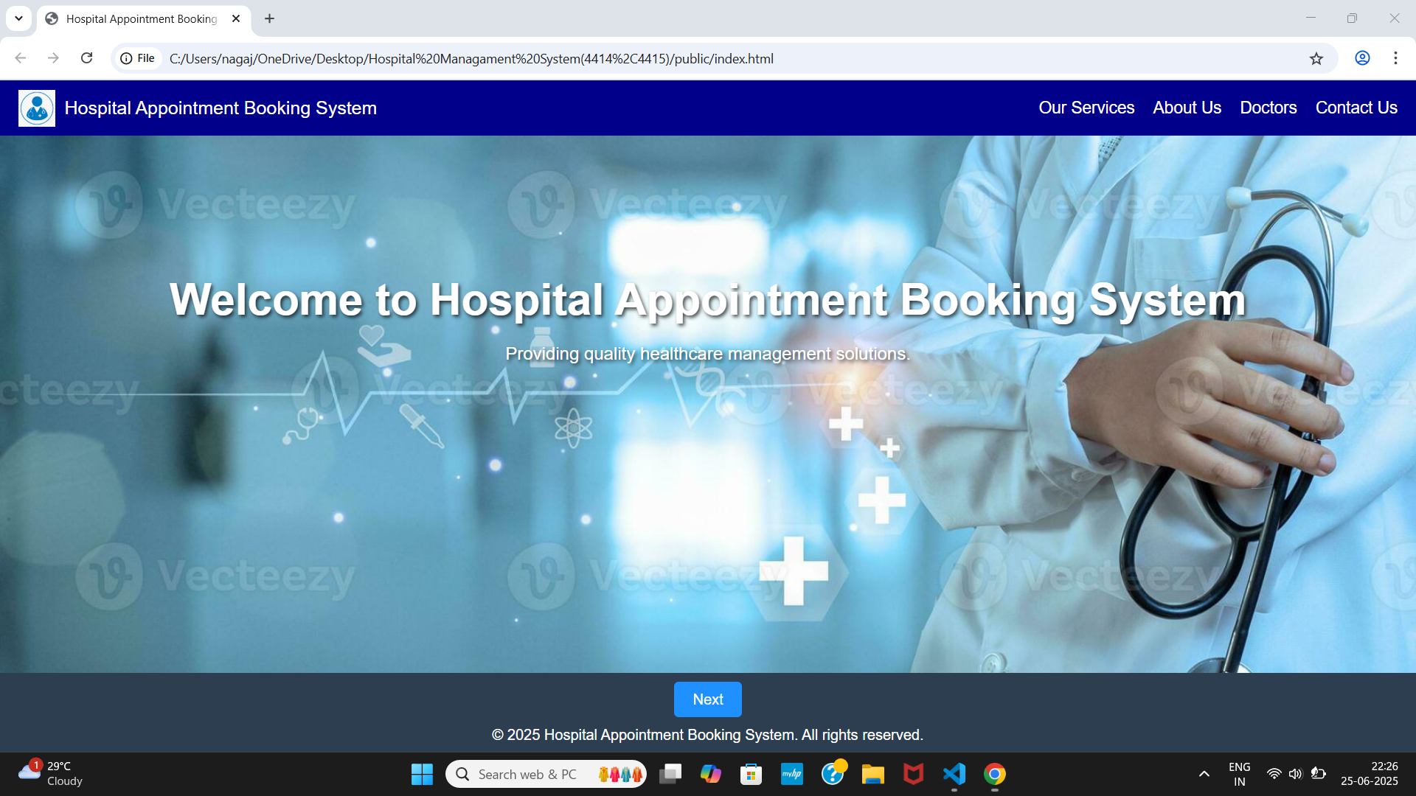

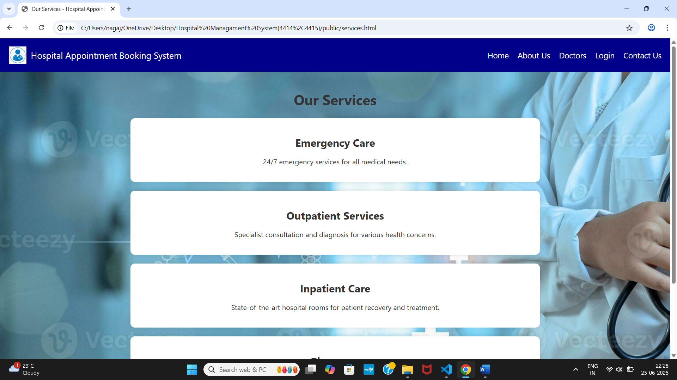

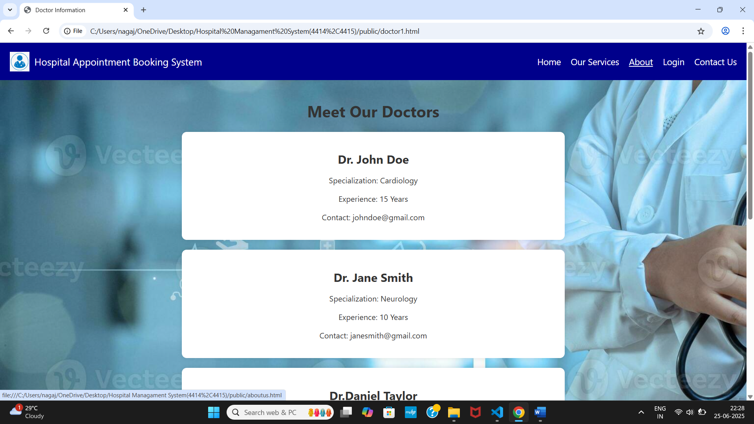

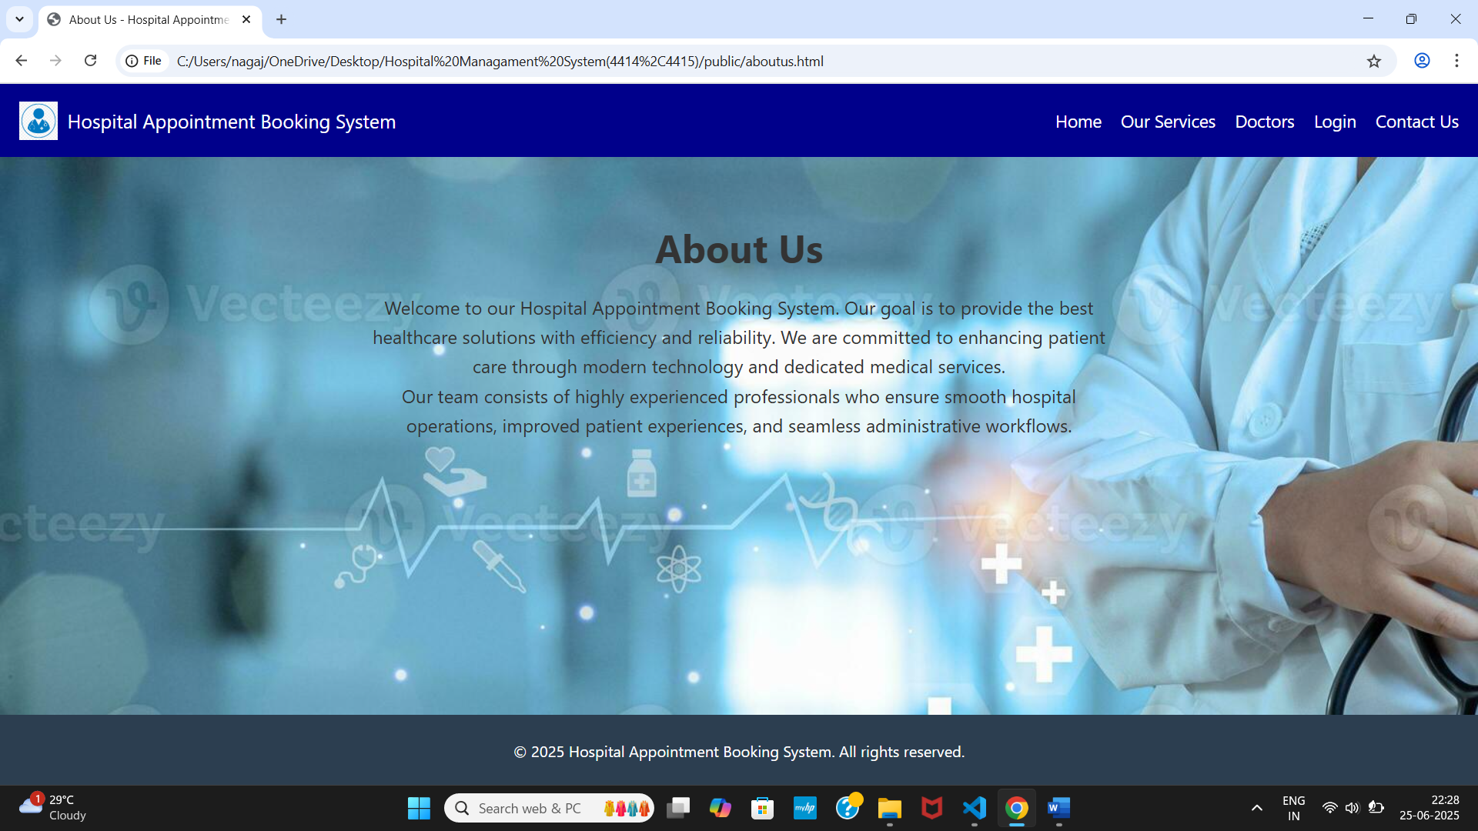

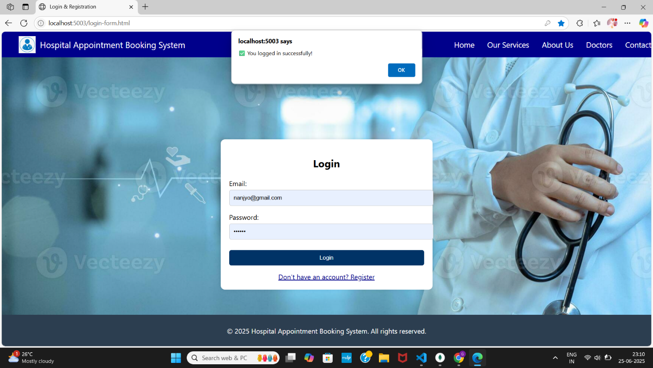

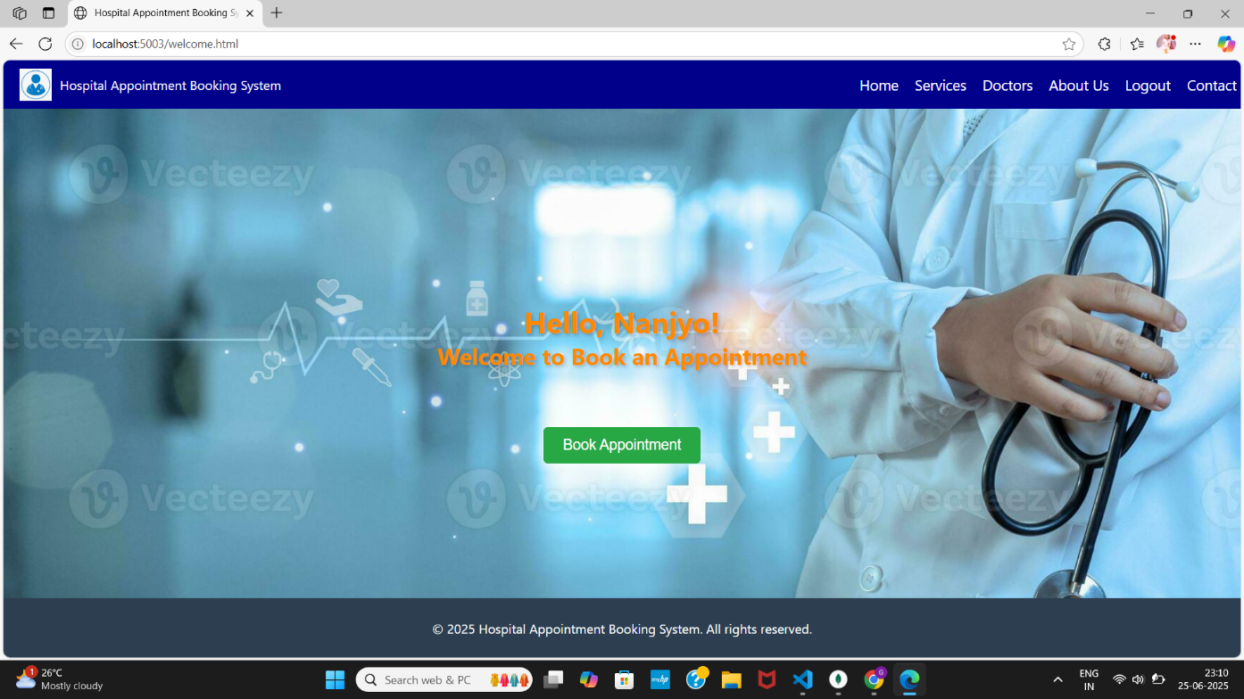

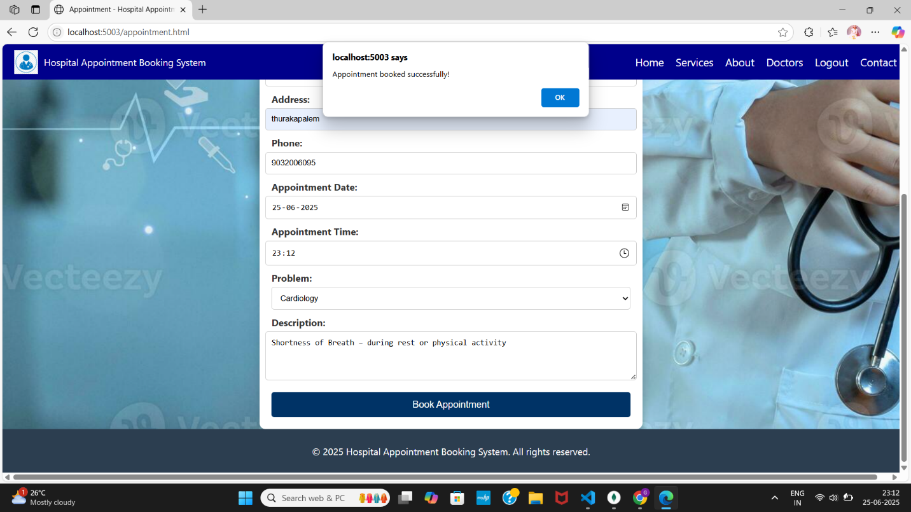

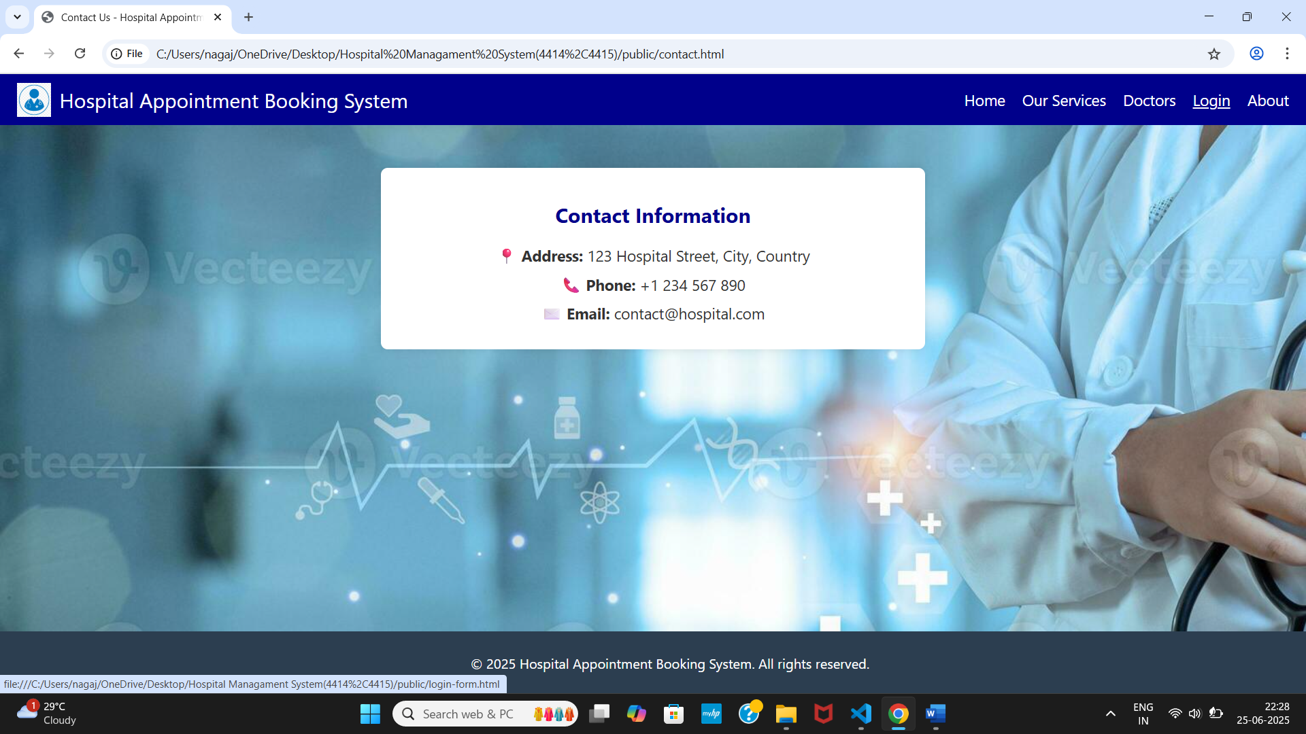

**MongoDB Screenshots:**

